
EEEN 462 – ANALOGUE COMMUNICATION
SINGLE-SIDEBAND MODULATION - STUDY GUIDE/REVISION

1. INTRODUCTION TO SSB
- Definitions
(a) Single Sideband Modulation (SSB) is an amplitude modulation technique that transmits only one sideband (USB or LSB) while suppressing the carrier and the other sideband.
(b) Hilbert transform is a mathematical operation that shifts all frequency components of a signal by -90° without changing their amplitudes.
- Purpose of SSB Modulation
SSB modulation improves spectral efficiency and power utilization compared to DSB-AM or full AM.
- Key Features
  - Bandwidth is equal to the message bandwidth (f_{m}), half of DSB-AM.
  - No Carrier eliminates carrier power wastage.
- Historical Context:
Developed for long-distance telephony and military communications to save bandwidth and power.
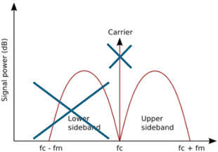
Figure 1. Principle of Single-Sideband Modulation: Carrier and One-sideband suppressed
2. MATHEMATICAL REPRESENTATION
- Time Domain Representation
If message signal is given by $m\left(t\right)= A_{m}cos\left(2πf_{m}t\right)$, the SSB signal is:
$$s\left(t\right)= A_{c}m\left(t\right) cos\left(2πf_{m}t\right)±\frac{A_{c}}{2}m'\left(t\right) sin\left(2πf_{m}t\right)$$

where
m’(t) is the Hilbert transform of m(t) (phase-shifts all components by −90º).
For Upper Sideband (USB): Use −, Lower Sideband (LSB): Use +.
- Frequency Domain Representation
  - USB Spectrum: $M(f-f_{c})$ for $f > f_{c}$
  - LSB Spectrum: $M(f+f_{c})$ for $f < f_{c}$
  - No carrier component at $f_{c}$

3. GENERATION OF SSB MODULATION
- FILTER METHOD OF GENERATING SSB
  - The filter method uses two stages as follows.
    - Generate DSB-SC signal: $s_{DSB}\left(t\right)= A_{c}m\left(t\right)cos⁡\left(2πf_{c}t\right)$
    - Pass through a bandpass filter (BPF) to select USB/LSB.
  - Challenge: Requires sharp-cutoff filters (e.g., crystal filters) for close sidebands.
  - Use Case: Commercial SSB transmitters.
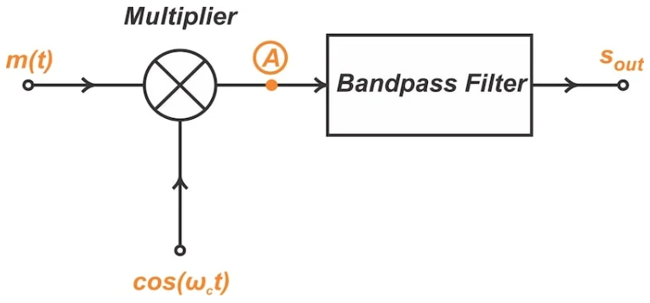
Figure 2. Filter method of generating SSB signal.

- TWO STAGE FILTER METHOD OF GENERATING SSB
Two-stage filter method for single-sideband (SSB) modulation is a technique used to generate SSB signals, particularly at higher frequencies, by dividing the modulation process into two stages to simplify the design of the filters required. It achieves this by first translating the modulating signal to an intermediate frequency (IF) and then to the desired high-frequency carrier, using bandpass filters at each stage.

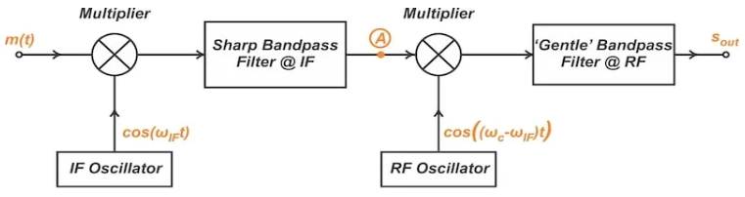
Figure 3. Two stage filter method of generating SSB signal.
Stage 1: The modulating signal is multiplied by a carrier signal at a relatively low intermediate frequency (IF) in a balanced modulator. The output of the balanced modulator is a double-sideband suppressed-carrier (DSB-SC) signal. A bandpass filter (BPF) is used to select either the upper or lower sideband of the DSB-SC signal. This selected sideband is then treated as a new baseband signal for the next stage.
Stage 2: The output of the first stage (the selected sideband) is multiplied by a second carrier signal at the desired higher radio frequency (RF). Again, a balanced modulator is used to generate a DSB-SC signal. A second bandpass filter then selects the desired sideband from this DSB-SC signal. The output of the second bandpass filter is the final single-sideband signal.
Advantages of 2 stages:
1. Cost Reduction: Designing sharp and selective bandpass filters for high-frequency SSB generation can be challenging and expensive. By using a two-stage approach, the filters in each stage can be designed for lower frequencies, making them easier and more cost-effective to implement.
2. Improved Filter Design: At higher frequencies, the roll-off of bandpass filters is more gradual, making it difficult to achieve good sideband suppression. The two-stage approach allows for sharper and more selective filters at lower frequencies, leading to better sideband rejection.
3. Flexibility: The two-stage method provides more flexibility in selecting the carrier frequencies for each stage, allowing for optimization of the overall system performance.

Further Reading:
Introduction to Single-Sideband Modulation: The Filter Method - Technical Articles

- PHASE SHIFT METHOD OF GENERATING SSB
The phase shift method for single-sideband (SSB) modulation utilizes two balanced modulators and Hilbert transform phase shifters to generate SSB signals. It involves shifting the phase of both the message and carrier signals by 90 degrees, then combining the modulated outputs to either suppress the lower or upper sideband.
    - Split m(t) into two paths as follows:
      - Path 1: m(t)cos(2πf_{c}t)
      - Path 2: m^(t)sin(2πf_{c}t)
    - Combine: s(t)=Path 1∓Path 2.
  - Advantage: Avoids need for sharp filters.
  - Challenge: Requires precise 90º phase shifts for all modulating signal frequencies.
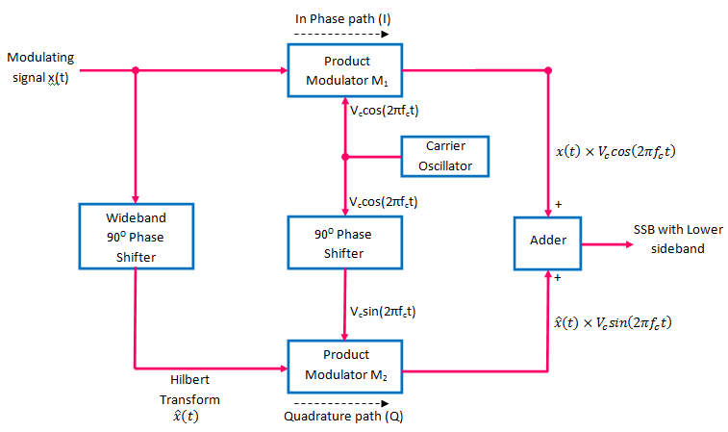
Figure 4. Phase Shift method of generating SSB signal.
Further Reading
Introduction to Single-Sideband Modulation: The Filter Method - Technical Articles

- WEAVER’S METHOD OF GENERATING SSB
Weaver’s method uses two stages to create the SSB signal as follows.
Stage 1: The message signal (audio signal) is multiplied by two signals: a cosine wave and a sine wave at a low audio frequency (f0), which is typically half the bandwidth of the message signal.
- This creates two signals: one with the spectrum shifted up in frequency by f0 and another shifted down by f0.
- These signals are then passed through low-pass filters to remove the unwanted sideband.
Stage 2: The filtered signals are then modulated by sine and cosine waves at a higher radio frequency (fc).
- The outputs of these modulators are then either added or subtracted to produce the upper sideband (USB) or lower sideband (LSB) SSB-SC signal, respectively.

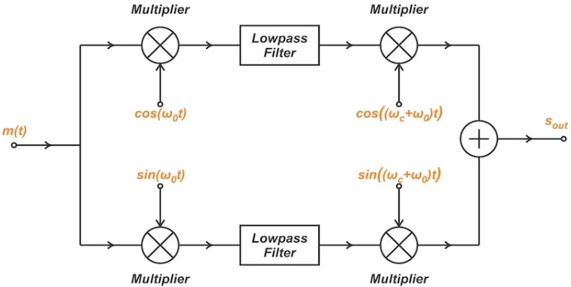
Figure 5. Weaver method of generating SSB signal.
Further Reading:
Introduction to Weaver’s Method for SSB Signal Generation - Technical Articles

4. SSB DEMODULATION TECHNIQUES
- COHERENT DETECTION:
Coherent detection (also known as synchronous detection) of SSB modulation involves using a local oscillator signal that is synchronized in frequency and phase with the carrier signal used to generate the SSB signal.
The synchronized signal is multiplied with the received SSB signal, and the resulting signal is passed through a low-pass filter to recover the original message signal.

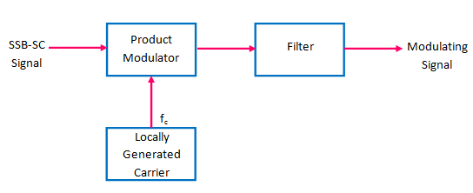
Figure 6. Block Diagram of coherent (synchronous) SSB demodulator

Requirements
    - Local oscillator synchronized in frequency/phase to the (suppressed) carrier.
    - Phase errors cause distortion.
Further Reading
https://electronicspost.com/explain-the-coherent-ssb-demodulation-with-block-diagram-what-is-phase-error-and-frequency-error-in-coherent-detection/

- PILOT CARRIER SYSTEMS:
A pilot carrier is a low-power, unmodulated sinusoidal signal that is transmitted alongside the suppressed carrier and sidebands. It's used primarily for synchronization purposes in the receiver, enabling accurate demodulation of the SSB signal.

Advantages of Pilot Carrier Systems
Reduced Distortion: By providing a stable reference, the pilot carrier minimizes distortion during demodulation.
Improved AGC and AFC: It can also be used for Automatic Gain Control (AGC) and Automatic Frequency Control (AFC) to compensate for signal fading and frequency variations.
Simplified Receiver Design: In some cases, it can simplify the receiver design compared to other methods like synchronous detection.
Application:
Used in broadcast systems.

- COSTAS LOOP:
Operating Principle
Recovers carrier phase from the SSB signal itself.

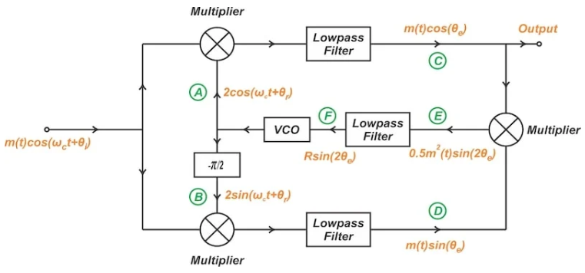
Figure 7. Block Diagram of Costas Loop
Further Reading
https://www.allaboutcircuits.com/technical-articles/demodulating-double-sideband-am-signals/

5. ADVANTAGES & DISADVANTAGES

Advantages | Disadvantages
Bandwidth efficiency (BW = f_{m}) | Complex generation/demodulation circuits
Power efficiency (no carrier) | Sensitive to frequency/phase errors
Less susceptible to selective fading | Poor SNR in weak-signal conditions
Longer communication range | Limited dynamic range for voice signals

6. APPLICATIONS
- HF Long-Distance Radio: Aviation, maritime, amateur radio (2–30 MHz band).
- Telephony: Legacy trunk lines and frequency-division multiplexing (FDM).
- Military Communications: Secure, low-probability-of-intercept (LPI) systems.
- Digital SSB: Modern software-defined radios (e.g., DRM for digital AM broadcasting).

7. COMPARISON OF SSB WITH OTHER TECHNIQUES

Parameter | AM | DSB-SC | SSB
Bandwidth | 2f_{m} | 2f_{m} | f_{m}
Carrier | Yes (high power) | Suppressed | Suppressed
Power Efficiency | ≤33.3% | 100% (sidebands) | 100% (sideband)
Complexity | Low | Moderate | High
Noise Immunity | Poor | Moderate | Good

8. PRACTICE PROBLEMS
- Problem:
A 1 MHz carrier is modulated by m(t)=2cos(2π⋅3000t)). Calculate USB and LSB frequencies.
Solution:
  - USB: 1000+3=1003kHz1000+3=1003kHz
  - LSB: 1000−3=997kHz1000−3=997kHz.
- Problem:
An SSB signal transmits USB with fc=10MHz and m(t) bandlimited to 300–3400 Hz. What is its bandwidth?
Solution:
BW=f_{m(max)−}f_{m(min)} = 3400−300=3.1kHz.
- Problem:
A DSB-SC signal at 1 MHz has sidebands at ±5 kHz. Design a filter method SSB generator.
Solution:
  - Use BPF centred at 1005 kHz (USB) with BW=5kHzBW=5kHz.
  - Filter roll-off must exceed 60 dB/decade to suppress LSB.

9. FURTHER READING
- Textbooks:
  - Communication Systems by Simon Haykin (Ch. 3).
  - Modern Digital and Analog Communication by B.P. Lathi (Ch. 4).
- Standards:
  - ITU-R HF Broadcasting Standards.
- Simulation:
  - MATLAB: ssbmod(), ssbdemod() functions.
  - GNU Radio: SSB transmitter/receiver flowgraphs.

10. KEY TAKEAWAYS
- SSB achieves 2× bandwidth efficiency over AM/DSB by suppressing the carrier and one sideband.
- Hilbert transform enables phase-shift-based SSB generation.
- Critical for spectrally crowded bands (e.g., HF radio).
- Trade-off: Complexity vs. Efficiency.

